Fisa de lucru 3

1.

|  |  |  |  |
| --- | --- | --- | --- |
|  | https://slack.com/intl/en-ro/ | font | culoare |
| 1 |  | “A better way to communicate” |  |
|  | https://www.shopify.com/ | font | culoare |
| 2 |  | “Start a business, with everything you need all in one place” |  |

|  |  |  |  |
| --- | --- | --- | --- |
|  | https://slack.com/intl/en-ro/ | background | pozitie |
| 1 |  |  |  |
|  | https://www.shopify.com/ | background | pozitie |
| 2 |  |  |  |

|  |  |
| --- | --- |
| https://wistia.com/ | https://slack.com/intl/en-ro/ |
|  |  |
|  |  |

3.

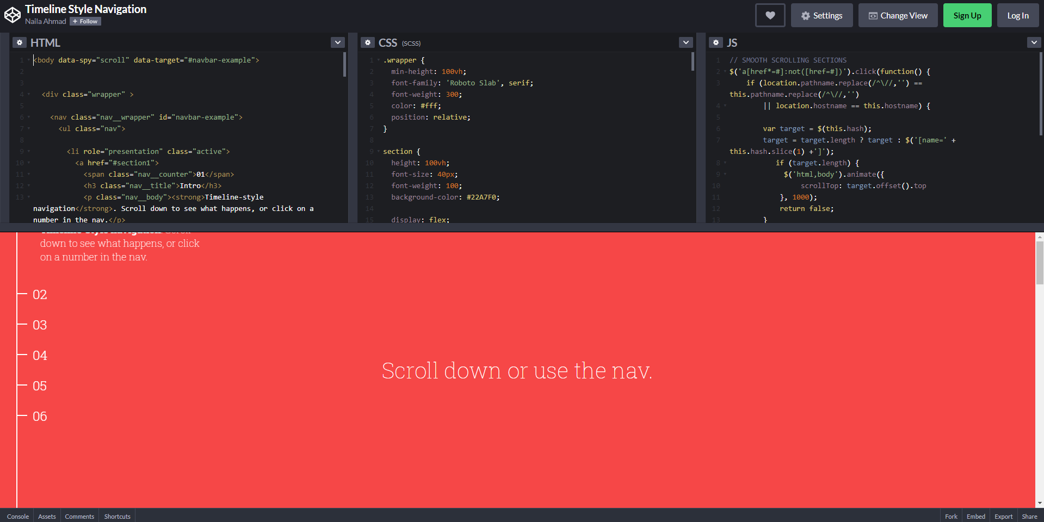

* Prin intermediul acestui cod se realizeaza derularea lina intre mai multe pagini ale unui site web

<https://codepen.io/nailaahmad/pen/MyZXVE>

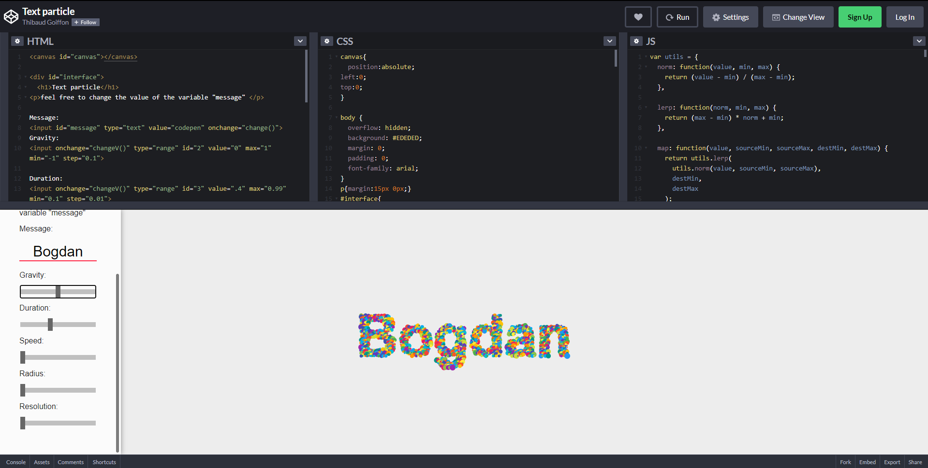

* Prin intermediul acestui cod se va modifica tipul de animatie a unui cuvant sal a mai multor cuvinte introduse prin schimbarea sensului de deplasare a bulinelor care formeaza cuvantul, viteza de deplasare, marimea lor si densitatea

<https://codepen.io/Gthibaud/pen/pyeNKj>

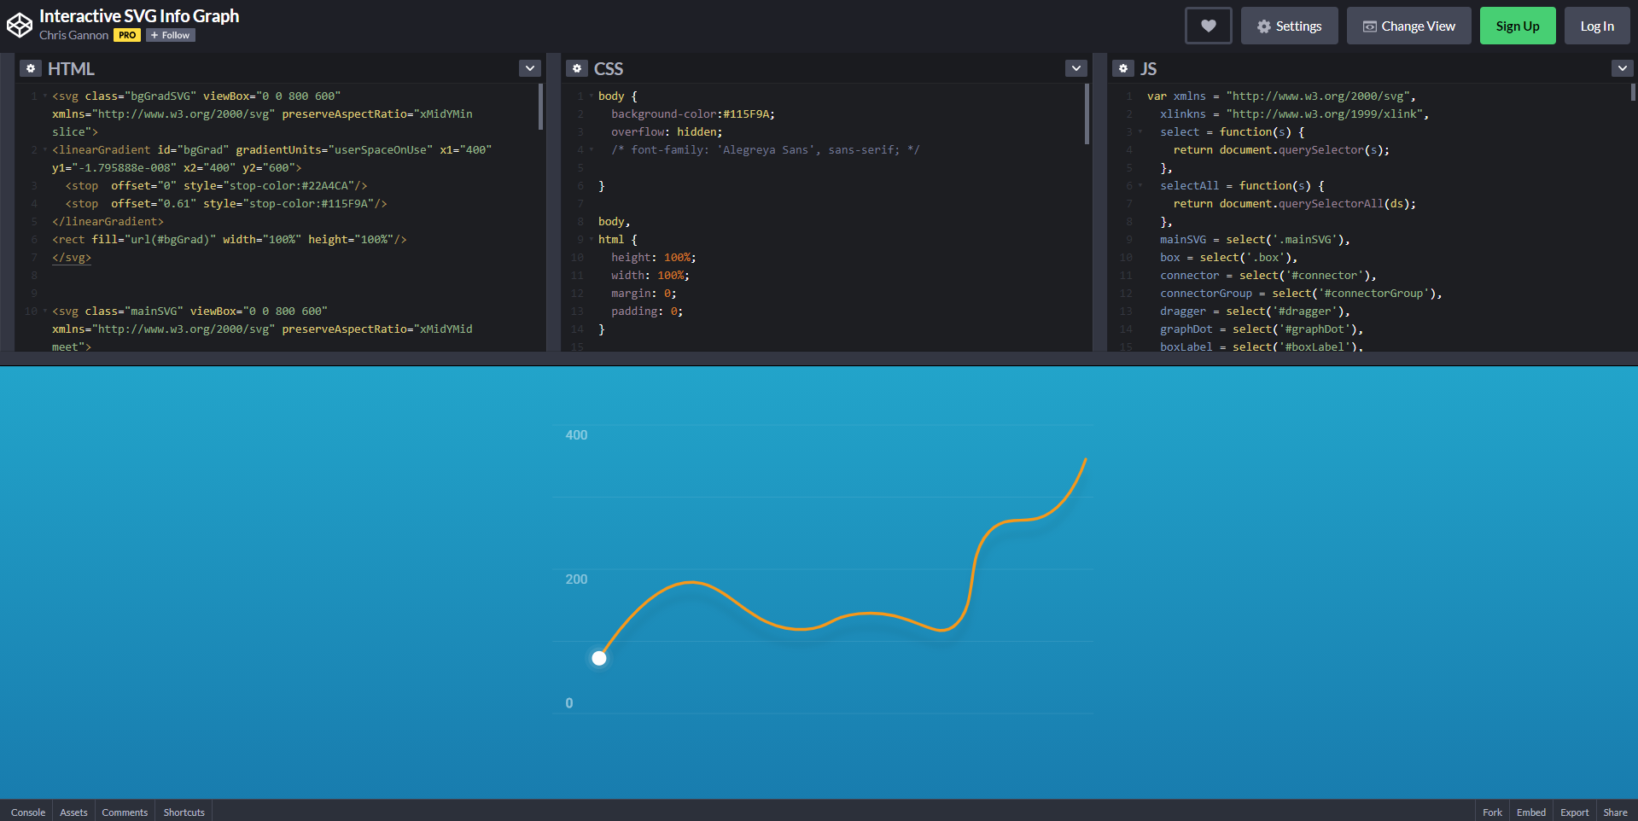

* Prin intermediul acestui cod se creaza o diagrama interactiva prin care se prezinta animat o statistica anume.
  + - * 1. <https://codepen.io/chrisgannon/pen/pbzEYr>

|  |  |
| --- | --- |
|  |  |
|  |  |
|  |  |

